Anywhere Print Web Client Instructions – workstation, tablet, smartphone
webprint.niu.edu
Enter_Username and Password

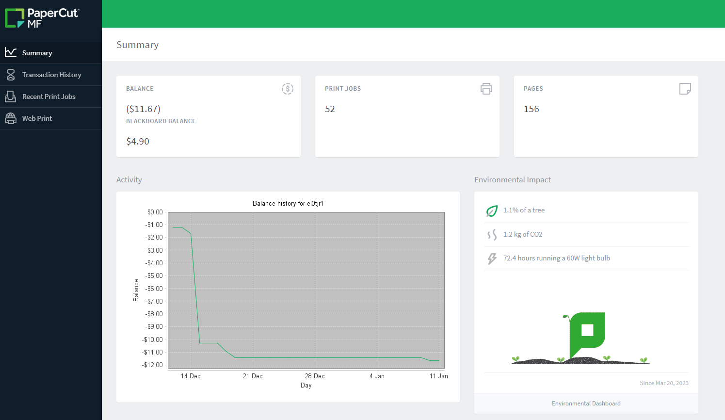
Select_Web Print

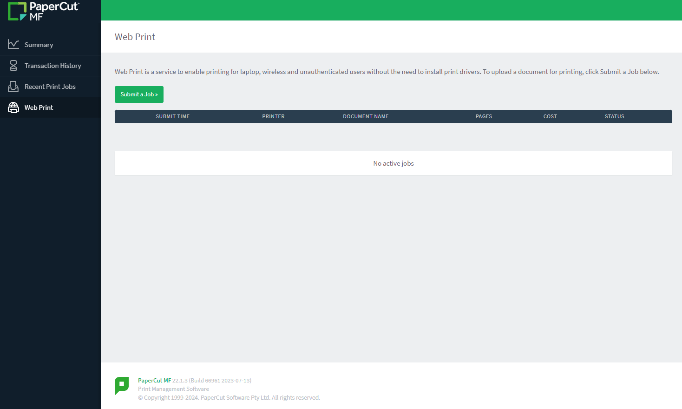
Select_Submit a Job

Select_pcprint1\PaperCut (virtual) or pcprint2\PaperCut (virtual)
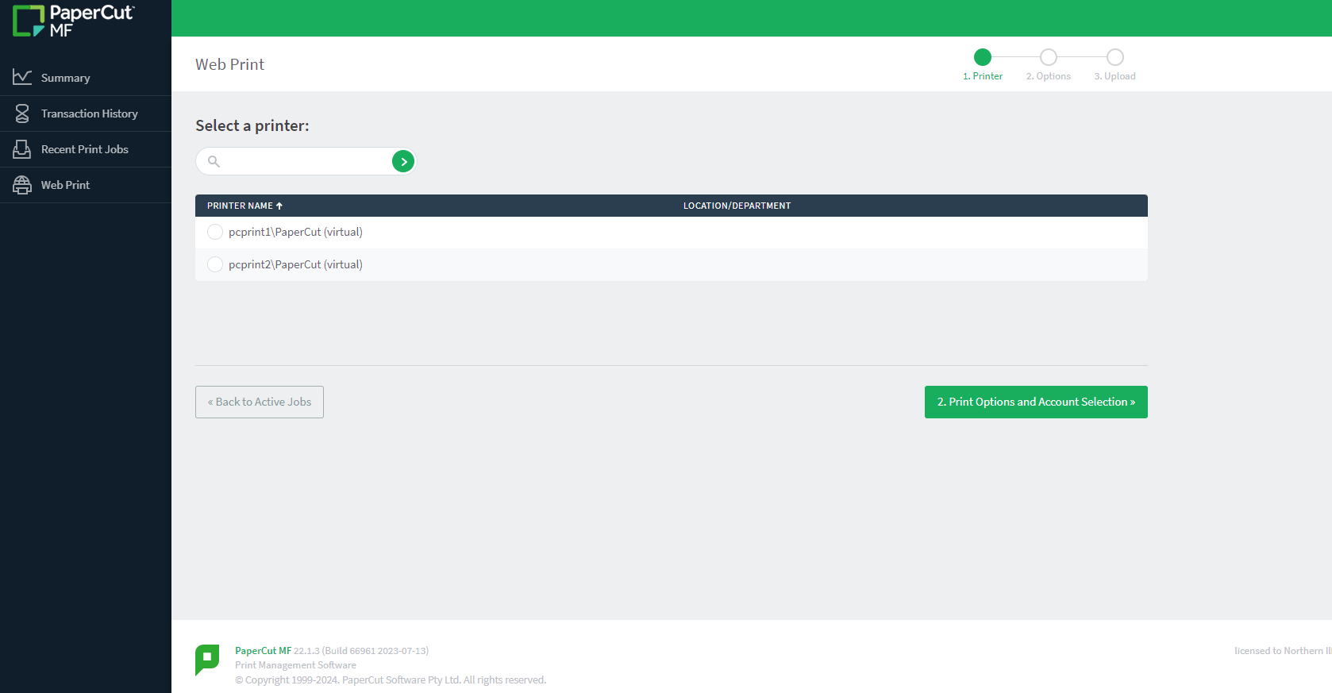
Select_2. Print Options and Account Selection

Select_Charge to my personal account or Charge to shared account
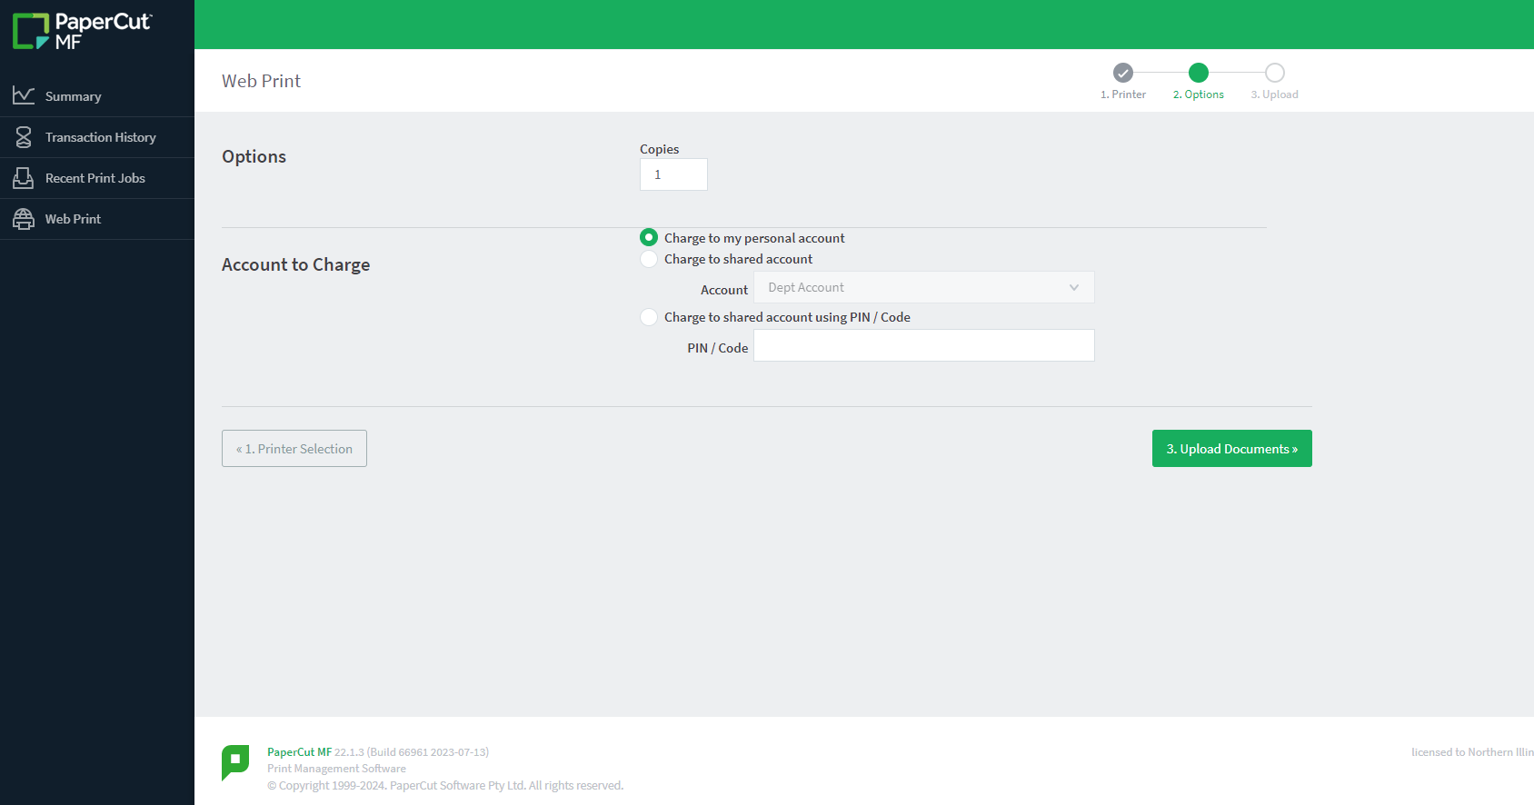
Select_3. Upload Documents

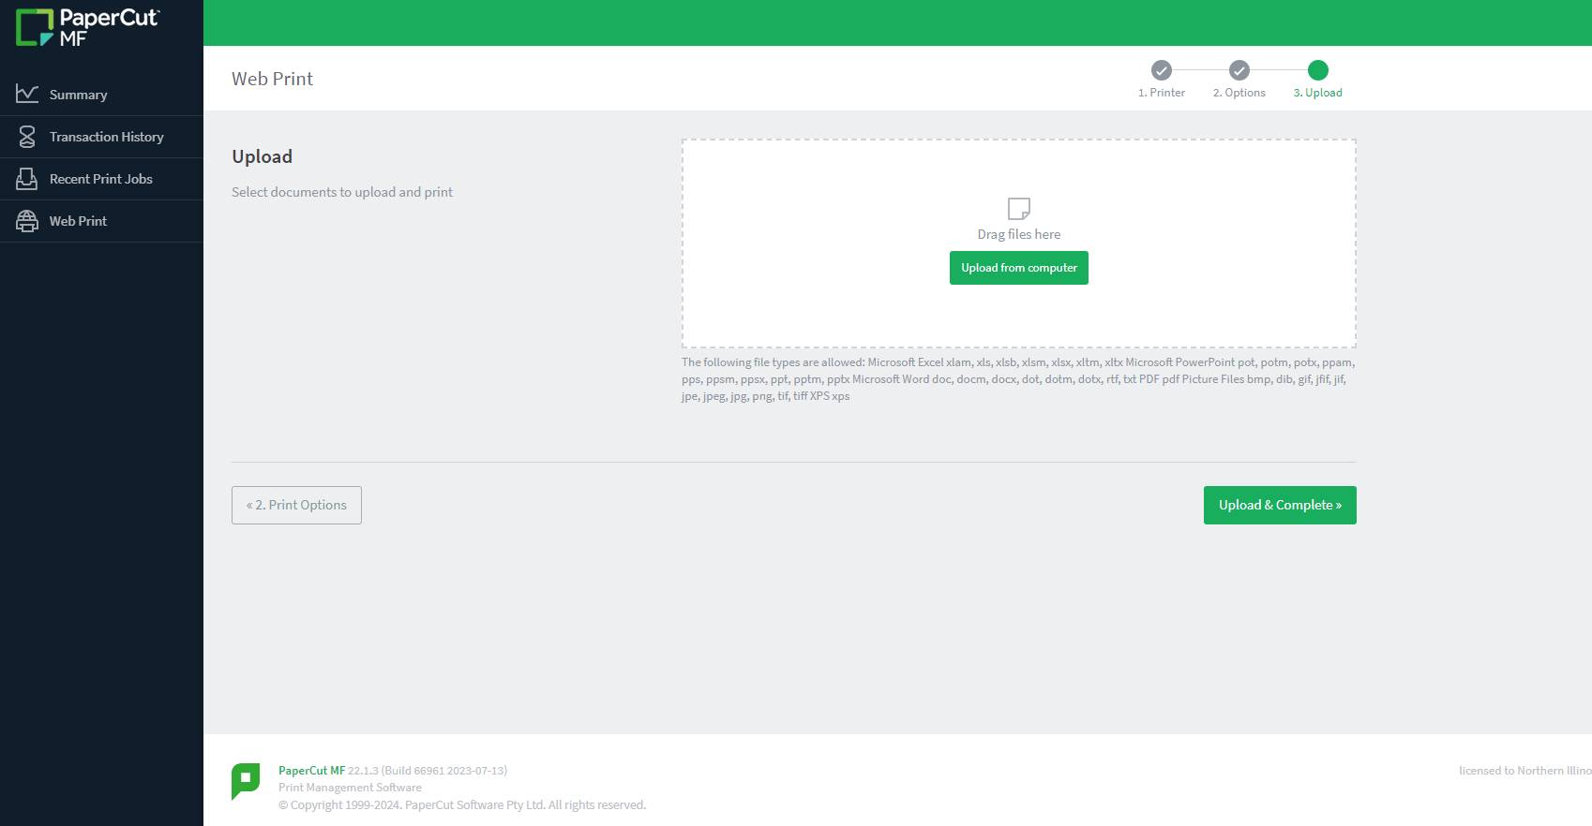
Select_Upload from computer

Select_Upload & Complete
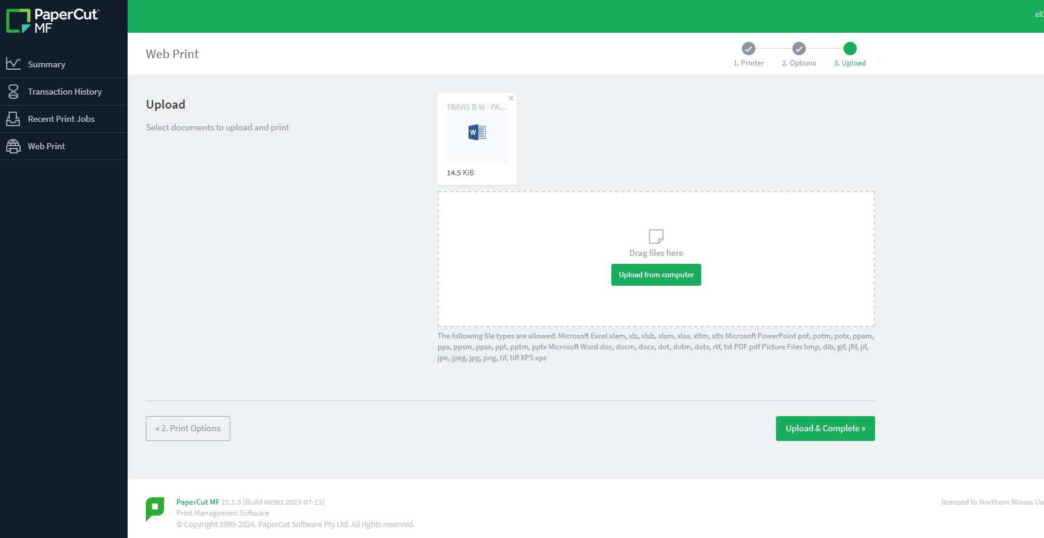

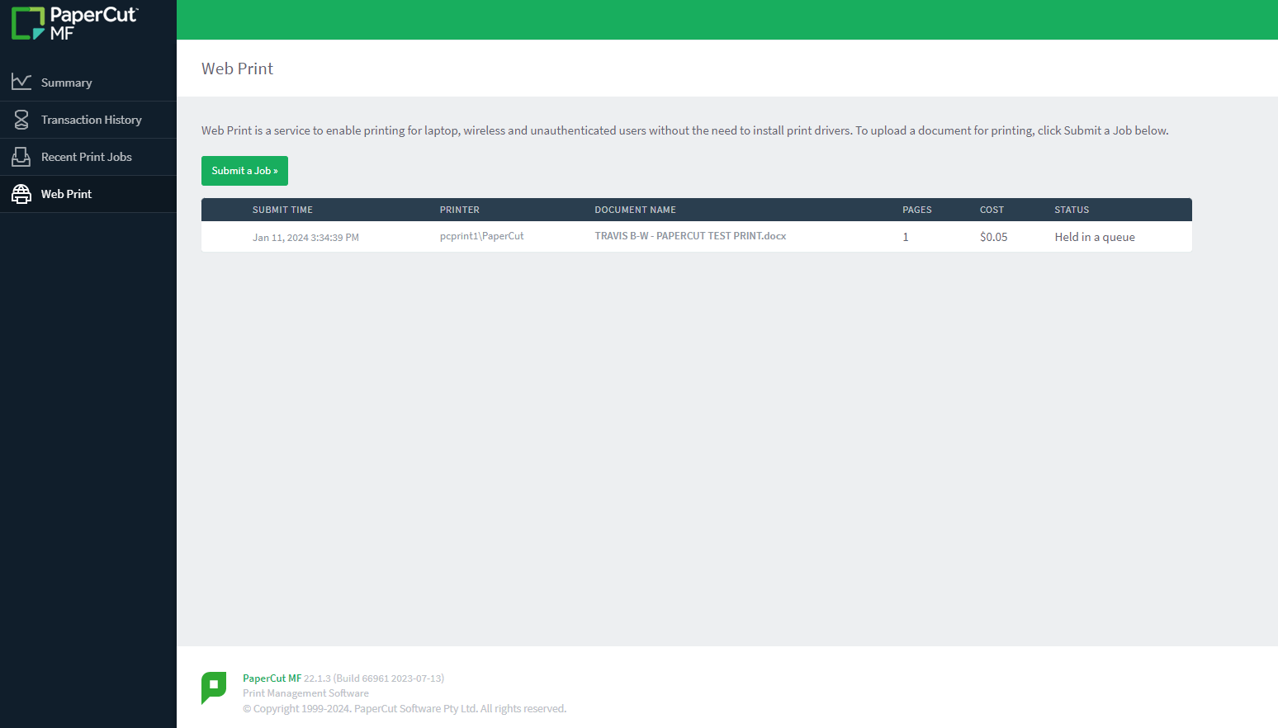
Status_ Held in a queue

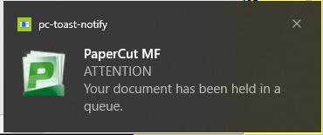
Screen notification of pending document ready for release at an AWP printer

